SIMATS ENGINEERING (SAVEETHA SCHOOL OF ENGINEERING)
Department of Computer Science and Engineering
CO4 ASSESSMENT TOOL 2 – CI/CD Pipeline Design Exercise

Course Code: | CSA1017 | Course Title: | Software Engineering
CO Assessed: | CO4 | Assessment: | Assessment Tool 2 – CI/CD Pipeline Design Exercise
Weightage: | 20% | Total Marks: | 25
CO4 Statement: | Implement robust testing, quality assurance, and DevOps practices, emphasizing security, reliability, and ethics
Student Name: | SHAKTHIVEL R | Reg. No.: | 192524325
Date: |  | Duration: | 60 minutes

Code of Conduct
I __________________________ (Name / Reg No) certify that this submission is my original work and that I have adhered to the guidelines specified for this assessment. I understand that any violation of academic integrity rules will result in disciplinary action.
Signature of the Student: _________________________
Annexure A – CI/CD Pipeline Design Exercise
Instructions to Students:
Each student is assigned an individual problem statement. Based on the assigned problem statement, design a CI/CD (Continuous Integration and Continuous Deployment) pipeline for the proposed software system to automate the processes of code integration, building, testing, and deployment.
The exercise should include:
- Analyze the project requirements and identify the CI/CD needs of the assigned problem statement.
- Design the CI/CD pipeline workflow showing stages such as source code management, build, testing, code quality analysis, packaging, and deployment.
- Identify suitable tools and technologies for each stage of the pipeline and justify their selection.
- Define appropriate automated testing strategies to be integrated into the pipeline.
- Design the deployment strategy, including development, testing/staging, and production environments.
- Incorporate appropriate security, quality checks, notifications, and rollback mechanisms in the pipeline.
- Prepare a CI/CD pipeline diagram and explain the workflow from code commit to deployment.
Deliverable: Submit a CI/CD Pipeline Design document containing the pipeline architecture/diagram, stages, tools, configuration/workflow, testing strategy, deployment process, and justification based on the assigned problem statement.

Rubrics for Calculation
Evaluation Criteria | Excellent (4 Marks) | Good (3 Marks) | Satisfactory (2 Marks) | Needs Improvement (1 Mark)
Requirement & Pipeline Analysis(15%) | Clearly analyzes the assigned problem and identifies comprehensive CI/CD requirements | Identifies most relevant requirements | Identifies basic requirements with some gaps | Requirements are unclear or incomplete
Pipeline Architecture & Workflow(25%) | Designs a complete, logical pipeline covering source, build, test, quality check, package, and deployment stages | Pipeline covers most major stages with minor gaps | Basic pipeline is designed but several stages are missing | Pipeline is incomplete or poorly structured
Tools & Technology Selection(20%) | Selects appropriate tools for each stage and provides clear justification | Appropriate tools selected with reasonable justification | Tools are identified but justification is limited | Tools are inappropriate or not clearly identified
Automated Testing & Quality Integration(15%) | Effectively integrates automated testing and code-quality/security checks into the pipeline | Includes major testing and quality checks | Includes basic testing with limited integration | Testing/quality checks are missing or inappropriate
Deployment, Security & Rollback Strategy(15%) | Clearly designs deployment environments, security practices, monitoring, and rollback strategy | Covers deployment and most security/rollback aspects | Basic deployment strategy with limited security/rollback details | Deployment strategy is incomplete or lacks security considerations
Pipeline Diagram & Documentation(10%) | Clear, accurate, professional diagram with excellent explanation and documentation | Well-presented diagram and documentation with minor issues | Adequate diagram/documentation but lacks clarity | Poorly presented, incomplete, or difficult to understand

Criteria | Mark
Requirement & Pipeline Analysis(15%) | /5
Pipeline Architecture & Workflow(25%) | /4
Tools & Technology Selection(20%) | /4
Automated Testing & Quality Integration(15%) | /4
Deployment, Security & Rollback Strategy(15%) | /4
Pipeline Diagram & Documentation(10%) | /4
TOTAL | /25

CI/CD PIPELINE DESIGN REPORT
Project Title: Intelligent AI-Based Smart Aquaculture Disease Prediction and Feed Optimization System
1. Project Requirements and CI/CD Needs
The smart aquaculture system combines a web application, AI/ML prediction services, data storage, and operational dashboards. Because changes can affect disease prediction, feed recommendations, and data handling, the development workflow requires automated testing, quality checks, security validation, reproducible packaging, and controlled deployment.
• Source code changes must be version controlled and reviewed before integration.
• Every integration should trigger automated unit and integration tests.
• Code quality and dependency/security checks should run automatically.
• A reproducible container image should be built only after checks pass.
• Staging deployment should occur before production release.
• Production deployment should support health checks, monitoring, notification, and rollback.
• AI model/version metadata should remain traceable to the deployed application version.
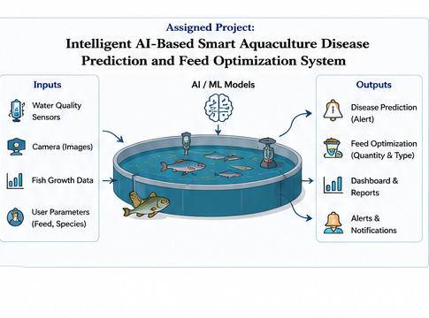
Figure 1. Generated smart aquaculture architecture illustration.

2. CI/CD Pipeline Architecture and Workflow
The proposed pipeline uses GitHub as the source repository, Docker for packaging, automated tests for validation, SonarQube for quality analysis, Trivy for image vulnerability scanning, and Kubernetes-based environments for staging and production. The exact tools are presented as the proposed design for the assigned system.
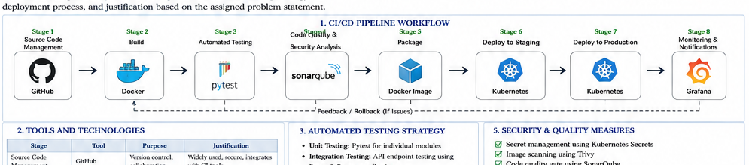
Figure 2. Generated CI/CD pipeline workflow from source control to monitoring.
Pipeline Stages
Stage | Activity | Input | Tool | Control
1 | Source Control | Developer push/pull request | GitHub | Branch protection and review
2 | Build | Install dependencies and build application | Docker | Reproducible container build
3 | Automated Test | Run unit/integration tests | pytest | Fail fast on defects
4 | Code Quality | Static analysis and coverage | SonarQube | Quality gate before packaging
5 | Security Scan | Scan dependencies and image | Trivy | Block critical vulnerabilities
6 | Package | Create and tag image | Docker Registry | Traceable artifact
7 | Staging Deploy | Deploy candidate version | Kubernetes | Integration verification
8 | Production Deploy | Approved release | Kubernetes | Controlled production rollout
9 | Monitor | Observe health/metrics/logs | Prometheus + Grafana | Detect failures quickly

3. Tools and Technology Selection
Pipeline Area | Selected Tool | Justification
Source code management | GitHub | Version control, pull requests and branch protection.
Build/package | Docker | Consistent runtime and portable application image.
Unit/integration testing | pytest | Simple automated Python test execution.
API testing | Postman/Newman | Repeatable endpoint validation.
Code quality | SonarQube | Static analysis, quality gates and coverage visibility.
Security scanning | Trivy | Container and dependency vulnerability scanning.
Image storage | Docker Registry | Central storage for versioned deployment images.
Deployment | Kubernetes | Self-healing, scaling and controlled rollouts.
Monitoring | Prometheus + Grafana | Metrics collection and dashboards.
Notifications | Slack / Email | Fast feedback on build, test and deployment events.
Tool Selection Rationale
The combination is appropriate because each tool has a focused role, while the pipeline connects them into a single automated workflow. GitHub controls collaboration, Docker standardizes packaging, pytest and Postman validate behavior, SonarQube and Trivy provide automated quality/security gates, Kubernetes provides environment orchestration, and Prometheus/Grafana provide operational visibility.
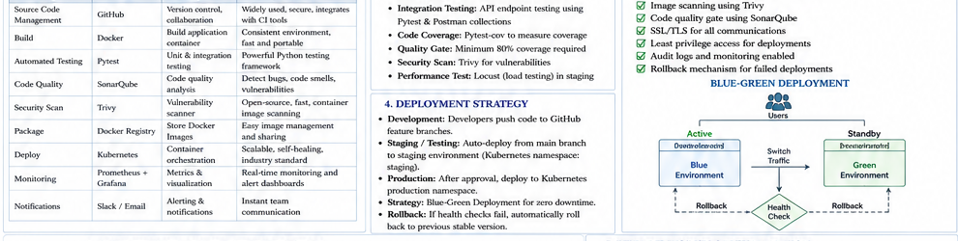
Figure 3. Generated CI/CD tools, testing, security, and deployment visual.
4. Automated Testing Strategy
The CI/CD pipeline should test the application at several levels. Testing is executed before a container image is promoted so that broken changes do not reach staging or production.
Test Type | Coverage | Tool | Trigger
Unit testing | Disease prediction utilities, feed calculations, validation functions | pytest | Every push/pull request
Integration testing | API routes, model service, database interactions | pytest + test client | Every pull request
API testing | Prediction, feed, authentication and health endpoints | Postman/Newman | Every main/develop integration
Security testing | Dependencies, container image and basic endpoint controls | Trivy + security checks | Before image promotion
Code quality | Complexity, maintainability, coverage | SonarQube | Every pull request
Performance testing | Response time under representative load | Locust | Staging/release candidate
Smoke testing | Health endpoint and critical user paths | Automated deployment checks | After each deployment
Quality Gates
• All unit/integration tests must pass.
• Configured minimum code coverage must be achieved.
• No quality-gate blocker should remain in the change.
• Critical or high-severity image vulnerabilities should block promotion according to project policy.
• Staging deployment must pass health and smoke checks before production approval.
Example CI sequence
-------------------
checkout -> install -> lint -> test -> coverage
-> sonar scan -> security scan
-> docker build -> image scan -> push

5. Deployment Strategy
The deployment process uses three environments: Development, Staging/Testing, and Production. This separation allows rapid development without exposing unstable changes to end users and ensures the production environment receives only a validated release candidate.
Environment | Typical Source | Purpose | Control
Development | Feature branches and local Docker setup | Fast developer feedback | Not production-facing
Staging | Validated main/develop build | Integration, smoke and performance testing | Controlled test data
Production | Approved release image | Stable farm-facing service | Protected access and monitoring
Blue-Green Deployment
For production, a blue-green strategy is proposed. The existing environment remains active while the new version is deployed to the alternate environment. After health checks and smoke tests pass, traffic is switched to the new environment. If the release fails, traffic can be switched back to the previous stable environment.
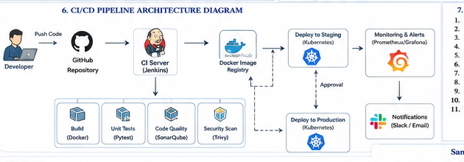
Figure 4. Generated deployment and rollback architecture.

6. Security, Quality, Notifications and Rollback
Area | Pipeline Control
Secrets | Store credentials and tokens in protected environment/secret stores; never commit them.
Dependency security | Run dependency and container vulnerability scans on the pipeline.
Access control | Require authenticated, least-privilege access to repositories and clusters.
Branch protection | Require reviews and passing checks before merging to protected branches.
Container security | Use minimal images, non-root execution where practical, and image scanning.
Transport security | Use HTTPS/TLS for application and service communication.
Auditability | Keep deployment and approval records linked to commit and image tags.
Data privacy | Avoid sensitive farm/user information in logs and test artifacts.
Notifications
• Notify the development channel when builds fail.
• Notify reviewers when pull-request quality gates fail.
• Notify the release channel when staging deployment completes.
• Notify responsible operators when production deployment, rollback, or monitoring alerts occur.
Rollback Mechanism
• Record every production image with an immutable version tag.
• Run post-deployment health checks and smoke tests.
• Automatically or manually revert traffic to the previously stable version if checks fail.
• Preserve logs and deployment metadata for root-cause analysis.
Rollback should restore service availability first, then investigation can proceed without leaving the production environment in an uncertain state.

7. CI/CD Workflow Explanation
Step | Activity | Expected Pipeline Behavior
1 | Developer commits or opens a pull request. | GitHub starts the workflow.
2 | Pipeline checks out the source. | The exact commit becomes the build input.
3 | Dependencies are installed and code is checked. | Formatting/linting errors fail the job.
4 | Unit and integration tests execute. | Functional defects stop promotion.
5 | SonarQube and security checks execute. | Quality/security gates must pass.
6 | Docker image is built and scanned. | Only an approved artifact is published.
7 | Image is deployed to staging. | Smoke and integration tests run against the deployed service.
8 | Release approval is recorded. | Production deployment is authorized.
9 | Production rollout occurs. | Blue-green or controlled rollout limits risk.
10 | Monitoring and notifications activate. | Failures trigger alerts and rollback procedures.
Illustrative Pipeline Configuration
name: smart-aquaculture-ci
on:
push:
branches: [ "main", "develop" ]
pull_request:
jobs:
test-and-quality:
runs-on: ubuntu-latest
steps:
- uses: actions/checkout@v4
- run: pip install -r requirements.txt
- run: pytest -q --cov=app
- run: docker build -t smart-aquaculture:${{ github.sha }} .
- run: trivy image smart-aquaculture:${{ github.sha }}

8. Monitoring and Reliability
The deployed system should expose health and readiness information so that the pipeline and runtime platform can determine whether the application is functioning correctly. Monitoring should cover application availability, API response time, error rate, model-service failures, database availability, and resource utilization.
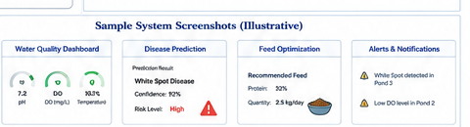
Figure 5. Generated illustrative application monitoring and dashboard screens.
Monitoring Area | Example | Purpose
Health check | /health | Returns service status and dependency checks.
Readiness | /ready | Confirms whether the instance can receive traffic.
Application metrics | Prometheus | Tracks requests, errors and latency.
Model metrics | Application metrics | Tracks prediction count, failure rate and confidence distribution.
Infrastructure metrics | Prometheus | Tracks CPU, memory and pod health.
Visualization | Grafana | Provides operator dashboards and trend views.

9. Quality and Ethical Considerations
• Model predictions are decision-support outputs and should include confidence/risk information rather than being treated as unquestionable facts.
• Training and validation data should be documented, and model versions should be traceable to deployments.
• Sensitive farm and user information should be protected and excluded from unnecessary logs.
• Pipeline automation should not bypass review or security gates merely to accelerate releases.
• False negatives in disease detection can be operationally serious, so model evaluation and alert thresholds must be carefully validated.
The generated figure summarizes the complete design: source control, build, testing, code quality, security scanning, packaging, staging, production, monitoring, notification, and rollback. It is an illustrative architecture figure rather than a screenshot of an actual deployed pipeline.
10. Expected Benefits
Benefit | Expected Outcome
Faster delivery | Automated verification reduces repetitive manual steps.
Higher reliability | Build/test/security gates catch problems before release.
Reproducibility | Docker packages the application with a consistent runtime.
Traceability | Commit hashes and image tags connect source code to deployments.
Safer releases | Staging, approval and rollback reduce production risk.
Better maintenance | Automated quality checks reveal regressions and technical debt earlier.

11. Challenges and Future Improvements
Challenge | Improvement
AI model dependency | A pipeline can validate software behavior, but model quality still depends on representative data and evaluation.
Long-running tests | Image/model tests may increase pipeline time; parallel jobs and staged test selection can help.
Deployment complexity | Kubernetes introduces operational overhead; managed services or simpler container platforms may be used for smaller deployments.
Security maintenance | Vulnerability databases and dependencies change continuously, so scheduled scans are required.
Sensor reliability | Real sensor inputs can be noisy or unavailable; validation, retry, caching and graceful degradation are needed.
Future Enhancements
• Add automatic model validation and drift monitoring to the release process.
• Use infrastructure-as-code for repeatable environment creation.
• Add deployment approval rules based on risk and change type.
• Use canary releases for high-impact prediction-service updates.
• Integrate end-to-end tests using anonymized sensor and farm data.
• Add signed container images and provenance metadata for release artifacts.
12. Conclusion
The proposed CI/CD pipeline provides an automated path from source-code commit to validated deployment for the Intelligent AI-Based Smart Aquaculture Disease Prediction and Feed Optimization System. It directly addresses the assessment requirements for pipeline stages, tool selection, automated testing, deployment environments, security, quality checks, notifications, rollback, and pipeline documentation.
By combining version control, automated tests, quality/security gates, containerized packaging, staging verification, controlled production rollout, and monitoring, the development process becomes more repeatable and easier to maintain. The architecture can later be extended with model-drift checks, canary deployment, infrastructure-as-code, and stronger release governance.
13. References
• GitHub Actions documentation for workflow automation.
• Docker documentation for container build and deployment practices.
• pytest documentation for automated Python testing.
• SonarQube documentation for code-quality analysis and quality gates.
• Trivy documentation for container vulnerability scanning.
• Kubernetes documentation for deployments, health checks and rollback mechanisms.
• Prometheus and Grafana documentation for monitoring and visualization.

